**Brooklyn torah gazette**

**For Parshas ki sisa 5779**

Volume 3, Issue 25 (Whole Number 121) 18Adar Rishon 5779/ Feb. 23 2019

**Printed L’illuy nishmas Nechama bas R’ Noach, a”h**

For a free subscription, please forward your request to [***keren18@juno.com***](mailto:keren18@juno.com)

**Rabbi Dovid Goldwasser**

**On How to Respect**

**Your Father-in-Law**

**By Daniel Keren**

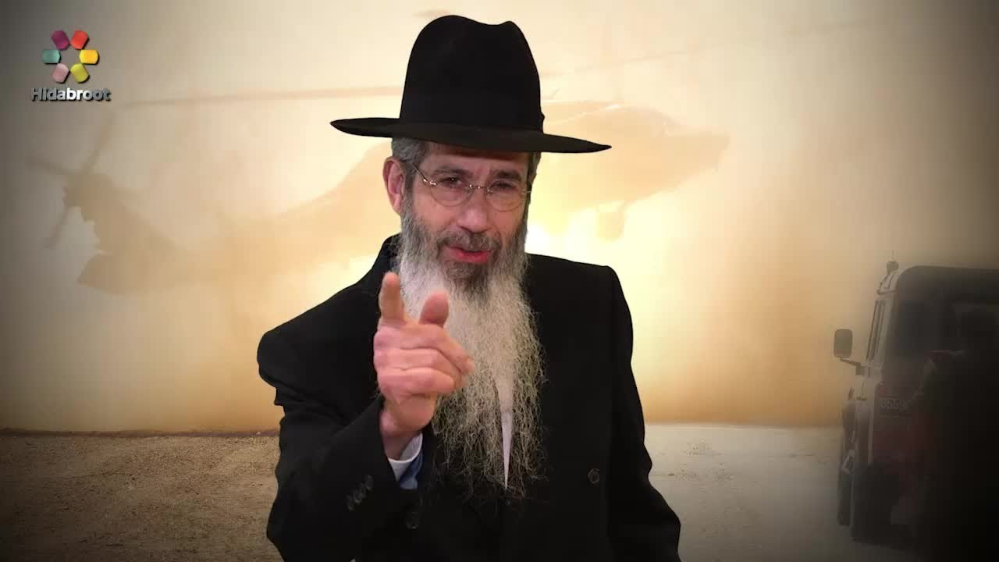

Rabbi Dovid Goldwasser was one of the featured speakers at last month’s Flatbush Martin Luther King Day Hakhel Yarchei Kallah Event. Rabbi Goldwasser is an internationally renowned Maggid Shiur and Rav of Congregation Bnai Yitzchok in Brooklyn. The topic of his lecture was “Halachic Perspectives for Our Times.” And he began with the subject of Shalom Bayis, by demonstrating proper respect for one’s In-Laws.

We see from Dovid Hamelech (King David), Rabbi Goldwasser says, that he would call his father-in-law, Shaul Hamelech (King Saul) “father” that one should honor his father-in-law just like his own biological father.

Unfortunately Chazal (our Sages of blessed memory) teach us in the Gemora that just preceding the coming of Moshiach, children and parents and certainly in-laws will not get along together. Therefore Eliyahu Hanavi (Malachi 4:6) will come to restore the hearts of parents to their children and the hearts of children to their parents.

What if your father-in-law or mother-in-law are having a serious financial difficulty. Should a son-in-law [or daughter-in-law] give most of their maiser money to help the in-laws? Rabbi Goldwasser said that in such a case such parents-in-law do become one of one’s main priorities for giving tzedakah. But it should done in a tactful manner that will honor the feelings of the party being helped.

Can parents tell their married child not to visit his in-laws because the parents had a falling out with their daughter-in-law’s parents? Rabbi Goldwasser answered absolutely no, because not only would this cause his child to violate the mitzvah of v’ahavta l’reacha kimocho, to love your fellow Jew as yourself, but it could also seriously weaken the important shalom bayis between the married child and his or her spouse.

Just how far does the concept of kibud av v’aim (honoring one’s parents and inlaws) go? If for example one’s father-in-law took his son-in-law’s wallet filled with $1,000 in cash and threw it far into the Hudson River. The best response, Rabbi Goldwasser said, would be for the son-in-law to just remain silent and not yell back or insult his father-in-law, as difficult as that may be.

In such cases, if the loss is a major imposition, the son-in-law does have the option to take his father-in-law to a beis din (a rabbinical court) in order decide on the halachic aspects and whether the father-in-law is obligated to make restitution for his damaging actions.

Another major problem that often comes up with in-laws relates to deciding the name of a grandchild. The halacha is that ultimately it is the parent’s choice of what name is given to the baby.

What if parents give money to their married children, do they have the right to insist on how the money is spent? The best solution would be to allow the children [if they are responsible] to spend the money as they see fit.

What is one’s married child is living in Eretz Yisroel and the parents want them to return to America (so they can enjoy them and also their grandchildren) and the children want to stay in the Land of Israel? Hacham Ovadia Yosef said that in such cases if the children don’t listen to their parents’ demands to return, they are not guilty of dishonoring their parents.

However, Hacham Ovadia did say that if one or both parents are not well and need the child’s assistance, it would then obligate the married child to return and help the parents and thus fulfill the mitzvah of kibud av’aim (honoring one’s parents.)

In other areas, Rabbi Goldwasser addressed the question of whether today with the new technology, one can fulfill an obligation to ask mechillah (forgiveness) by texting such a request. This ability to use such technology should not replace the human effort of physically requesting forgiveness of his or her fellow Jew.

Rabbi Aharon Leib Shteinman poskened (decided) that if during davening (prayers) the tzibbur shaliach (the one leading the services) was reciting Mishaberachs (a special prayer for the healing of sick people) and someone wanted to give the name of an ill Jew but didn’t know the sick person’s mother name, one could give the father’s name.

But what if even that parent’s name wasn’t known? In such a scenario, Rav Shteinman said that one can still offer a Mishaberach by reciting the first names of the ill person and including that individual’s hometown (i.e. Moshe Shlomo of Brooklyn or Sarah of Waterbury.)

Reprinted from the February 21, 2019 edition of The Jewish Connection.

**Thoughts that Count**

**For Parshas Ki Sisah**

*And the Children of Israel shall keep the Sabbath, to observe the Sabbath* (Ex. 31:16)

The holiness of Shabbat exists independently of the Jew; all he is enjoined to do is guard it. Yet at the same time, the Jew is commanded to observe Shabbat by his own actions, adding to its inherent holiness with his preparation and service.

*(Sefer Hamaamarim Tav Shin)*

Every Jew is given an extra G-dly soul on the Sabbath, which is why we are especially careful in keeping its laws: G-d is always more stringent with those He is closest to. *(Ohr Hatorah)*

*Reprinted for Issue #259 of L’Chaim Weekly edition for Parshas Ki Sisah 5753/1992.*

**Rav Avigdor Miller on the**

**Silver Lining of Frigid Weather**

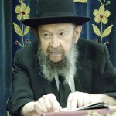

**QUESTION:** **How do we benefit from this cold weather?**

**ANSWER:** The benefits of cold weather are tremendous. Cold weather causes the earth to stop producing. If the earth would continue to produce all year round, it would use up all of its resources - all of its nutrients and energy. And that's why deserts are found in hot climates.

You won't find any deserts in cold climates. Because in temperate climates the earth always has a chance to recuperate its powers. In the hot climates however, sometimes the sun shines continuously with such heat, and the earth continues to produce and produce until it becomes arid and finally loses all its energy.

So the cold weather is mamash a yeshuah, a lifesaver. The cold weather is the reason that next year there will be crops again. The crops are a result of the cold weather that gave the earth a chance to recuperate. So next summer, when you're about to bite into a delicious peach, remember to thank Hakodosh Boruch Hu for the cold winter that prepared the earth to give you this peach. And when you walk in the cold today, remember to thank Hashem for all the delicious fruit that the cold weather is preparing for you.

You know, the earth uses up all of its energy to produce for us. But when the cold comes, all the leaves fall onto the ground. And the leaves are fertilizer. After a while they melt away into the ground. And now comes the cold weather and there's no more growing. Everything stops growing. The earth stops producing.

What does the earth do? It recycles. It recycles all the energy that it had lost and the earth becomes fertile once again. And now in the springtime it is ready to produce again. So the cold is actually a lifesaver for us. Without cold there would be deserts all over America. But the dry deserts are found only in the areas with hot climates like the Sahara or the Arabian deserts because the sun is shining there all year round. **TAPE #E-210 (January 2000)**

*Reprinted from the February 5, 2019 email of Toras Avigdor adapted from Tape #E-210 (January 2000).*

**Leadership Qualities**

**By Rabbi Moshe Meir Weiss**

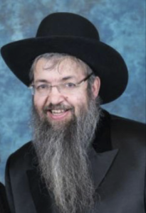

In contemporary society, respect for our leaders is almost extinct. We’ve become cynical to the extreme – feeling that our leaders frequently talk out of both sides of their mouths, saying not what they believe but what they think you want them to say, and following the polls rather than their morals and beliefs.

It is, therefore, very educational, reassuring, and refreshing to see in the beginning of Sefer Shmos the development and leadership qualities of Moshe Rabbeinu, one of the greatest leaders of all time. From these lessons, we can hopefully absorb what to aspire to and how to train our children.

When Moshe Rabbeinu first met up with Hashem by the burning bush, the verse tells us that Moshe said, “Let me turn now and investigate this amazing sight.” Rav Avigdor Miller, Zt”l, Zy”a, points out that if Moshe Rabbeinu did not have an eagerness and desire to learn – as manifested by his turning and investigating, and he would have instead gone on his own way, he would have missed out totally on the revelation. Thus, we see a first step in greatness is the trait of always yearning to learn more.

As a young man, raised with royal treatment in Paroh’s palace by the Princess Bisya, Moshe Rabbeinu did not allow himself to relax in splendor. Rather, he went out to his suffering brethren and shared in their fate. This is the great quality that we find in all of our leaders; namely, “Nosei b’ol im chaveiro — Sharing in another’s suffering.” Thus, Rebbetzin Kotler, Zt”l, did not put sugar in her coffee or tea all the years of the holocaust. And too, right now, many American Jews are praying feverishly, sharing in the plight of our brethren in Eretz Yisroel.

When Moshe Rabbeinu saw an injustice being committed against one of his brethren, he didn’t consider his security or his comfort, but rather acted with alacrity in the defense of his own. Then, upon seeing the misbehavior of some of his brethren, he did not concern himself with the repercussions, but immediately chastised them properly. How many lessons can leaders learn from the study of Moshe Rabbeinu, even in his youth!

Of course, another stunning attribute of Moshe Rabbeinu was his unparalleled humility. His was not a leadership motivated by the need for accolades or fanfare. His captaincy was not fueled by a desire for power or adoration. For seven days and seven nights, he valiantly attempted to turn down Hashem’s offer of rulership of His people. This speaks volumes for the correct motivation for our aspiring young leaders.

Then, we watch in awe on how Hashem trained Moshe Rabbeinu to pray for his archenemies, Paroh and Mitzrayim. Moshe repeatedly did this to remove the successive plagues from Egypt. I believe this was to train Moshe Rabbeinu in the important leadership quality of being able to pray for, and help even, his antagonists. Thus, in the desert, Moshe Rabbeinu was able to care lovingly for a nation about which he himself would testify, “Od me’at u’skaluni — A little bit more and they would stone me.” In a similar vein, we find that Mordechai, although he was only, “Ratzui l’rov echav — Favored by some of the people,” he was, “Doveir shalom l’chol daro — Sought peace for all of the people.” This is a tough test of leadership – to be able to care for, and help, even the malcontents and the antagonists.

Moshe Rabbeinu’s willingness to sacrifice personal ambition for the benefit of the Klal is yet another extraordinary example of his greatness as a leader. Upon coming down from Har Sinai, he reached the zenith of his dreams, bringing down G-d’s Torah to his people. Yet, he willingly sacrificed and smashed it in order that the perpetrators of the golden calf should be spared from defying the written words that he held in his hand. So too, with awesome courage he declared, ”If you do not forgive them Hashem, “Macheini na mi’sifricha — Blot me out from your Torah.”

We all know the famous Medrash that when Moshe was a shepherd, a lone sheep wandered far from the flock. Upon finding it, Moshe Rabbeinu saw that it was ill and carried it back upon his shoulders. Hashem commented, “You displayed such compassion to one of your flock, I desire you to lead My flock.” Thus we see that mercy, compassion, kindness, and care are necessary components of true Jewish leadership.

Let’s not fall into the trap of being cynical about our own leaders. It is very natural that when someone criticizes us, we react by taking him or her down a peg or two. It is much easier to tear them down and negate their words than to consider that we might be wrong – and need improvement. This is one of the most frequent reasons why people disparage their own Rabbi’s, while still manifesting great respect for other Rabbonim. It is not only because they grow weary and used to their own Rav over the years. It is also because the other Rabbonim have not repeatedly chastised them personally.

Furthermore, let us not succumb to the easy habit of always suspecting our own Rabbis and Roshei Yeshiva of doing things for the sake of kavod. Let us rather consider that by elevating the stature of our leaders, we are ensuring that our children will look up to them, be more likely to listen to them, and have a greater desire to be like them. In short, let’s aspire to the reward of the Talmud, “One who honors Rabbonim will have children who are Talmidei Chachomim.”

As we learn Sefer Shmos and learn about Geulas Mitzrayim, may we all merit the final redemption speedily in our days.

*Reprinted from the February 12, 2019 website of Matzav.com.*

*Before all your people I will perform wonders, such as have not been done on all the earth, nor in any nation* (Ex. 34:10)

The Hebrew word for "wonder" is related to the word meaning "set apart." G-d promised the Jews that they would be set apart from the rest of the nations of the world, for His Divine Presence would henceforth rest only on them. But what "wonders" were promised?

Not merely miracles in the physical world, but wonders in the spiritual sense, a deeper understanding of G-dliness and holiness than is afforded others. That is why the verse specifies "before all your people," for only the Jew can really understand and appreciate the depth of these wonders. *(Ohr Hatorah)*

*Reprinted for Issue #259 of L’Chaim Weekly edition for Parshas Ki Sisah 5753/1992.*

**The Secret Power of the**

**Knot of G-d’s Tefilin**

**From the Talks of the Lubavitcher Rebbe**

**Rabbi Menachem Mendel Schneerson, Zt”l**

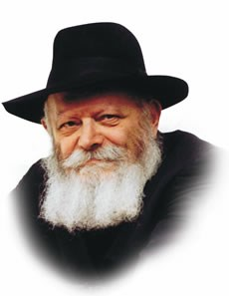

**The Lubavitcher Rebbe, zt”l**

This week's Torah portion, Ki Tisa, contains an interesting exchange between Moses and G-d. "Show me, I pray, Your glory," asks Moses. G-d replies, "You cannot see My face...you will see My back, but My face shall not be seen."

The Torah is obviously speaking in symbolic terms. "Face" refers to a clear and unequivocal revelation of G-dliness, in much the same way that an individual's face reveals his inner self; glimpsing a person's "back" reveals far less about the person. But what did G-d show Moses?

The great commentator, Rashi, explains that G-d showed Moses the knot of His tefillin (phylacteries). What kind of answer to Moses' petition was that?

In order to understand, we must first place the exchange in its proper context. Moses made this request after the Jews sinned by making the Golden Calf. After such a grave sin, how could they ever be forgiven? What possible merit did the Jews have for G-d to absolve them of idolatry? Rashi explains that G-d's answer was to teach Moses the proper way for a Jew to pray for Divine mercy.

Sin itself defies logic. How could it be that a Jew, a member of a nation described as "believers, the children of believers," should sin? How can a Jew, who believes in his innermost heart that G-d created the world and continues to sustain it every minute of the day, denies this by transgressing G-d's will?

The answer is that all sin stems from forgetfulness. It is only when a Jew forgets the true nature of the world that he transgresses; when he forgets that G-d is the only absolute reality he strays from the right path. The minute a Jew is reminded of this, there is no room for sin and it ceases to exist.

This, then, is the significance of the knot of the tefillin. If sin is only the result of a Jew's forgetfulness, he need only be reminded of G-d and he will not transgress. This is accomplished by the tallit and tzitit (ritual fringes), whose purpose is to remind the Jew of his task in life, as it states in the Torah, "And you shall see it, and remember." The tefillin serve the same purpose: "And it shall be as a remembrance between your eyes."

Most specifically, it is the knot of the tefillin which symbolizes this, as a knot serves both as a reminder (such as when one ties a knot around one's finger to remember something), and as a symbol of the binding knot between G-d and the Jewish people.

By showing Moses the knot of the tefillin, G-d was instructing him how to seek atonement, for if we always bear in mind that there is nothing but G-d, there is no room for sin.

*Reprinted from the Parashat Ki Sisa 5773/1992 edition of L’Chaim Weekly, a publication of the Lubavitch Youth Organization in Brooklyn, NY.*

**The Shmuz on****Parshas Ki Sisa**

**For the Love of Money**

**By Rabbi Bentzion Shafier**

**Founder of TheShmuz.com**

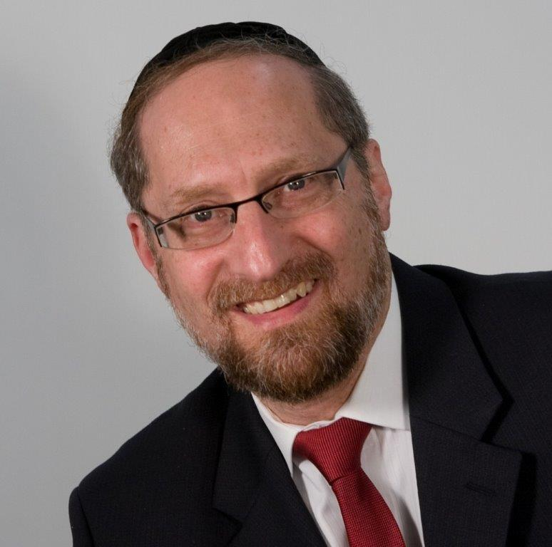

**Rabbi Bentzion Shafier (The Shmuz.com)**

“*Moshe returned to HASHEM and said, “Please! This people has committed a grave sin and made themselves a god of gold*.” – Shemos 32:31

When Moshe Rabbeinu came down from *Har Sinai*, he found a very different scene than the one he left forty days earlier. A segment of the Jewish nation, in rebellion against HASHEM, had formed a golden calf and was worshiping it. The rest of the nation stood by and didn’t protest. In context, this was such an egregious act that HASHEM threatened to destroy the entire nation.

Rashi explains that during the process of asking for forgiveness, *Moshe Rabbeinu* said to HASHEM, “*You caused this. You gave the Jewish people gold and silver; they left Mitzraim with great riches. Isn’t it obvious that they would come to sin?”*

This Rashi seems difficult to understand when we focus on who these people were and where this was taking place.

The *Klal Yisroel* was living in the desert. They neither worked for a living nor had any use for money. All of their needs were taken care of. They ate *Mon* that was delivered to their tents daily. They drank water from the *Be’er*, the rock that followed them in their journeys. Their clothes were washed by the *Clouds of Glory*, and their shoes never wore out. They didn’t need money and couldn’t use it. How could it become their downfall?

**The Real Danger of Wealth**

The answer to this question is based on understanding why the *Misilas Yesharim* calls wealth one of the great tests of man.

Materialism and self-indulgence are the risks of affluence, but an even greater danger is that wealth can lead a person to view himself as *different* than everyone else. “There are regular people, but I am different because I am rich. The world is full of people, but I am in a different category. I am a *rich man*.”

With this also comes a sense of self-sufficiency and arrogance. “I am a wealthy man, so I don’t need anyone. I don’t need my children. I don’t need my wife. In fact… I am so wealthy that I don’t really need HASHEM.”

The danger of wealth is the sense of being a rich man

This seems to be the answer to this Rashi. Granted the Jewish people living in the desert needed nothing and could do nothing with their money, but the real risk of wealth is the sense of superiority that comes along with it. In their minds, they were now rich. As rich men, they were significant, important, too big to be dependent upon anyone, and this feeling was the root cause of their rebellion against HASHEM.

**Who Were These People?**

This concept becomes a tremendous chiddush when we take into account that these individuals were on a higher level than any other generation in the history of mankind. They had been slaves in *Mitzraim* and were freed. They had lived through the entire process of the *Maakos* and splitting of the *Yam Suf.* They watched as HASHEM showed total dominion over every facet of nature.

But more than all of this, they had only recently stood at the foot of *Har Sinai* when HASHEM opened up the heavens and the earth and revealed the greatest secrets of Creation. They had seen and experienced HASHEM more clearly than did the greatest *Naviim*, which tells us that they knew exactly why they were created and how passing and insignificant is a person’s station in this world. And yet *Moshe Rabbeinu* compared their being wealthy to such a difficult test that it would be like putting a young man on the doorstep of sin.

This is highly illustrative of the inner workings of the human. HASHEM created deep within our hearts many needs and desires. One of these is the need for honor and prestige. The drive for *Kavod* is one of the strongest forces in man. Often we are unaware of its existence until a given situation brings it to the fore.

While the *Klal Yisroel* were then living in the ultimate Kollel community, money still had value to them – not in what it could buy, but in its more alluring sense, in the associated feeling of power and importance that it brought. They were now rich people, and that sense is so dangerous that it can destroy even the greatest of men. For that reason, Moshe said to HASHEM, “You caused this. The gold and the silver that You gave them brought them to sin.”

**Living in Our Age**

This concept has particular relevance in our day and age. Never in the history of mankind have so many enjoyed such wealth. On some level, each of us has the opportunity of “one day being rich.”

As with many life situations, prosperity can be either a blessing or a curse. If a person changes because he is now a rich man, he needs more, he feels that he deserves only the best, and he won’t be satisfied with what *everyone else gets by with*. That sense of superiority will turn him against his Creator, and the very wealth that he acquired will be the source of his ruin. For eternity, he will regret having been given that test – which he failed.

However, if a person remains aware that he was granted wealth for a purpose – that he is not the owner of it, but rather its custodian, duly charged with its proper use – then he can use it as a tool to help him accomplish his purpose in existence. His wealth will then be a true bracha that he enjoys in this world, and for eternity, he will enjoy that which he accomplished with it.

*Reprinted from this week’s website on TheShmuz.com This is an excerpt from the*[*Shmuz on the Parsha book*](https://theshmuz.com/product/shmuz-on-the-parsha-book/)*.*

**Rabbi Berel Wein on**

**Parashat Ki Sisah**

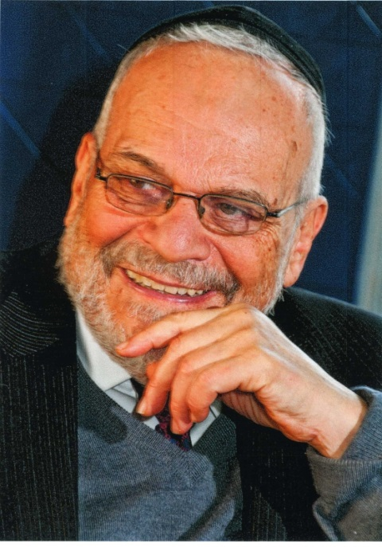

Population numbers do matter and they matter greatly. This is undoubtedly one of the many messages communicated to us in the Torah reading of this week. We see throughout the Torah that the Jewish people are counted often and in fairly exact detail.

This is because there is an obvious lesson that has to be absorbed within Jewish society and that is that in order for Judaism and its value system to continue to operate and be of influence in world society, there must be a physical Jewish people.

There is no Judaism without Jews. And even though we are relatively small in number, when compared to the billions of others that inhabit our planet, the number of Jews that are in the world is a very important matter. One of the more worrisome developments in the Jewish world after World War II has been the lack of any real increase in the Jewish population.

Apparently, there were 19 million Jews in the world in 1939 and about 13 million Jews in the world in 1945. Since then – almost 80 years later – the overall Jewish population in the world is estimated to be only about 15 million people. And this number undoubtedly includes many people who call themselves Jewish but who under many interpretations of Jewish law are not really Jews.

It was estimated in 1950 that there were about 6 million Jews living in the United States. Though no real accurate account is available today, estimates range between 4.5 million to 7.5 million Jews. Again, this estimate does not take into account Jewish law, but rather only deals with people who identify themselves as being Jewish. As one can see this is a woeful and tragic situation.

There are many factors that go into this population crisis in the Jewish world. Very high rates of intermarriage never produce Jewish children in any meaningful way. There is a tendency for Jews in the Western world, particularly in the United States, to place education and profession above marriage, family and children. There is also a general social feeling in the world that personal comfort and happiness is all that is important, which is juxtaposed to marriage and raising children which might engender sacrifice and stress.

Statistics have shown that large families with many children, are only found amongst Orthodox Jews throughout the Diaspora. Here in Israel the birth rate is, thank G-d, high and stable, even in much of the non-Orthodox community. Again, except for the Orthodox,  Jewish communities in the diaspora are rapidly shrinking and the prognosis for the future is very clouded and dire.

At the beginning of the 19th century, the Jewish population in Europe had shrunk to about 3 million Jews. By the beginning of World War II, it had risen to approximately 11million Jews. This enormous growth over a short period of time enabled the Jewish people to somehow weather the storm of the Holocaust and rebuild itself in the miraculous fashion that it has done here in Israel and throughout the world. But we should always remember that numbers matter.

*Reprinted from this week’s website of Rabbiwein.com*

*\*\*\*\*\*\*\*\*\*\*\*\*\*\*\*\*\*\*\*\*\*\*\*\*\*\*\*\*\*\*\*\*\*\*\*\*\*\*\*\*\*\*\*\*\*\*\*\*\*\*\*\*\*\*\*\*\*\*\*\*\*\*\*\**

*Before all your people I will perform wonders, such as have not been done on all the earth, nor in any nation* (Ex. 34:10)

The Hebrew word for "wonder" is related to the word meaning "set apart." G-d promised the Jews that they would be set apart from the rest of the nations of the world, for His Divine Presence would henceforth rest only on them. But what "wonders" were promised?

Not merely miracles in the physical world, but wonders in the spiritual sense, a deeper understanding of G-dliness and holiness than is afforded others. That is why the verse specifies "before all your people," for only the Jew can really understand and appreciate the depth of these wonders. *(Ohr Hatorah)*

*Reprinted for Issue #259 of L’Chaim Weekly edition for Parshas Ki Sisah 5753/1992.*

**Rabbi Eli J. Mansour**

**On Parashat Ki Tisah**

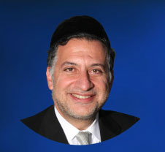

In Parashat Ki Tisah we read about the tragic episode of the Egel, which was when Jews worshipped the golden calf. And we read about Moshe Rabenu’s reaction when he came down from the mountain on Har Sinai and saw what was going on, and he threw the Tablets from his hands and they came down and shattered, and they broke into pieces in front of all the Jewish people.

The Rabbis question Moshe Rabenu’s approach of breaking the Tablets.  He could have placed the Tablets on the side of the mountain and maybe come down and give them a speech, or give them Musar talk. Why did he have to go to the extreme and actually smash the Tablets that had the word of G-d on it?

The Mefarshim learn from this a lesson in education or a lesson in Musar, that sometimes it is appropriate for the leader to use shock tactics. Which means if Moshe Rabenu would have started screaming on top of the mountain and for example would have yelled out, “Rabotai it is forbidden, Rabotai it is a transgression”, it would have fallen on deaf ears, for the people were so engrossed in the Avoda Zara (idol worshipping) and in their reveling, and they wouldn’t have heard him nor accepted it.

So Moshe Rabenu had to do something drastic. Moshe Rabenu had to do something to catch the attention of the people, so he had to throw the Tablets.  So when the people all of a sudden saw the Tablets tumbling down they were shocked to their core so much so that until the end of Moshe Rabenu’s life the Jewish people never worshipped Avoda Zara again.  So you see the tactic actually worked.

There was an interesting question that somebody once asked Rav Moshe Feinstein. At the time there was various pathological testing being done on autopsies of Jewish people.  And the question was asked to Rabbi Feinstein, would it be permissible to take the limbs of those bodies that are being cut up and used for these tests, and display them at a rally to illustrate to the people what was going on. The goal was to awaken the people of the severity of the crime of cutting open Jewish bodies.

By showing them the actual limbs themselves, maybe the shock would inspire them to make changes. Rav Moshe Feinstein replied that in this specific case it would be permissible.  It was based on the concept that sometimes we have to go to extreme measures in order to give the people a wake-up call and catalyst to amend their ways.

In our time just a few years ago, Bore Olam gave us a modern version of a shock attack, which was the destruction of the Twin Towers. At the time, as you might remember, everybody was scared.  Nobody was able to believe that jet liners could be flown into buildings, and that the buildings actually came crumbling down and thousands of people died.  It is no question that Bore Olam does such things in order to shock us.

Unfortunately there are many shock attacks that we are having today in Israel, with all the terrorist bombings and the blowing up of busses and innocent people.  We hear on the news of 10 casualties and 20 casualties, and we hear of occurrences throughout the world.

These are shock attacks that Bore Olam is giving us in order to wake us up, because today’s generation has become so deafened to the words of Musar. No longer does it help for a sermonizer to get up and start giving rebuke. People say we heard it already and we know this already.  Bore Olam is shaking the world to its core in order to get people to change.

Let us not waste these different messages that Bore Olam is using.  Let it stand as a motivation for change for things to get better, and Be’Ezrat Hashem, Bore Olam will bring peace and tranquility in the world. No longer will shock tactics need be used. No longer will the method of breaking of the Tablets be needed.  Israel will receive the message and hear what G-d wants from them.  And they shall return to their roots and live with fear of G-d, Amen.

*Reprinted from this week’s website of the Edmund J. Safra Synagogue in Brooklyn, NY.*

**Latest Rebbe Mendel**

**Stories to Tease Yeshiva Students of All Ages**

**By Daniel Keren**

(Nathan Sternfeld’s REBBE MENDEL: Snow Joke and Other Tales, Feldheim Publishers, 2018, 226 pages, translated from the Hebrew edition Hakad Hashavur by Brocha David and illustrated by David Bichman.)



The eleventh volume of the Rebbe Mendel stories – “Snow Joke and Other Tales” by Nathan Sternfeld was published last June for Jewish juvenile readers throughout the English-speaking world and continues a joyous tradition beginning with the author’s first volume of “Adventures with Rebbe Mendel) that was published in 2002. It is basically aimed at Bar Mitzvah aged boys from more traditional rightwing yeshivas as opposed to more modern Orthodox yeshivas or Day Schools.

One would assume that Nathan Sternfeld is in real life a rebbe in an Israeli chareidi (or more ultra-Orthodox) yeshiva who like the protagonist Rebbe Mendel in his series of books attempts to excite his talmidim (pupils) into pursuing the answers to important Torah concepts with puzzling questions for his students to try and solve.

The new volume “Snow Joke and Other Tales” begins with Rebbe Mendel confessing his dilemma to his talmidim. A children’s magazine wants him to write a story for their readers on some intriguing aspect of the holiday of Succos that has a connection to the number “seven” and while he has stories in his repertoire about the numbers 900, 34, 703 and minus 4, the rebbe is stumped for a delightful story connected to the number 7 which relates to the number of days in the festival of Succos. To find out Rebbe Mendel’s solution turn to Chapter 2 titled “The Seven Stars.”

In the third chapter titled “The Fifth Question,” we learn how a father was able to inspire his son Pinchas in 19th Century Germany to swim against the tide when almost all his young classmates were abandoning the Torah lifestyle.

Another Rebbe Mendel chapter deals with the question of why outside of Eretz Yisroel, the Jews don’t celebrate a Ninth Day of Chanukah. In the same chapter the challenge of developing an improved way to raffle off prizes to his students and how the concept of the Ninth Day of Chanukah played an important role in the solution along with colored marbles.

Then there is the humorous difficulties that a quiet boy from Haifa confronts when beginning studies at the Ponevezh Yeshiva in Bnei Brak. Having the last name Sternfeld, he is constantly mistaken as coming from the Sternfeld of the housewares business.

Other tales to delight the juvenile boy reader include “Which Class Does the Table Belong to?”, “The Riddle that Refused to Surrender,” “The Rug Man’s Reasoning,” “Reb Nochum and the Seven Liquids,” “The Shattered Vase,” and “On the River Ulai.”

“On the River Ulai” tells of the trials and tribulations of a formerly assimilated Jewish family that immigrates from Russia to Eretz Yisroel and struggles to find Jewish names as befitting for living in a Jewish homeland, including the last name Ulai that is mentioned as the name of a river in Sefer Daniel, the Book of Daniel.

Towards the end of the book we come across the three-part “Snow Joke” stories that begins with a crash landing at the North Pole. What is the halachic significance of such a happening? The author explains:

“In the coldest winter months, the water in the Bering Strait (which separates Siberia from Alaska) freezes. As a result, any Russian, including Igor Kazimirski, one of the starring characters in our story, could simply travel on foot from Russia to the United States.

“Dear Readers:

“You must take what I am saying with the utmost seriousness, because this has very important halachic ramifications. Let’s say a person makes a condition that he is marrying Miss X only if it is possible for her to travel on foot from Haifa, in Eretez Yisroel, to New York.

“Please note! This wise guy did not say that he actually wanted or needed her to come on foot from Haifa to New York, just that it should be possible for her to do so. He thinks he’s kidding, but it’s really no joke. Oh no, not at all. The marriage would be halachically binding, because technically such a thing is possible. Not only is it possible, but it really quite simple; it just takes a very long time.”

If you want to find out just how Miss X can make that journey from Haifa on foot to New York, you’ll have to read the rest of the story that continues on page 143.

And for those of you who would like to find out why a rabid anti-Chareidi Jewish organization called ARC (Against Religious Coercion) decided to go out of business you’ll have to read Rebbe Mende;’s five-part series of stories called the “War of the Moshavnikim.”

Readers can find Nathan Sternfeld’s (not from the Sternfelds of the housewares, of course) eleventh volume of Rebbe Mendel Tales (“Snow Joke and Other Tales) at Jewish bookstores or by contacting the publisher by either calling (800) 237-7149 or click www.feldheim.com